13-11-2015

Mariano Orozco García

Procesamiento de señales biológicas, 3BM4

Tovar Corona Blanca

Convolution and correlation

Practice 4

***Practice 4 – Convolution and correlation***

***INTRODUCTION:***

Correlation and convolution are basic operations that we will perform to extract information from signals. These operations have two key features: they are shift-invariant, and they are linear. Shift-invariant means that we perform the same operation at every point in the image. Linear means that this operation is linear, that is, we replace every pixel with a linear combination of its neighbors. These two properties make these operations very simple; it’s simpler if we do the same thing everywhere, and linear operations are always the simplest ones.

**Convolution**

In mathematics, convolution is an operation on two functions f and g, producing a third function that is typically viewed as a modified version of one of the original functions, giving the area overlap between the two functions as a function of the amount that one of the original functions is translated.

Generalizations of convolution have applications in numerical analysis and numerical linear algebra, and in the design and implementation of finite impulse response filters in signal processing.

**Correlation**

Correlation is a mathematical operation that is very similar to convolution. Just as with convolution. The result is called cross-correlation of the two input signals. If a signal is correlated with itself, the resulting signal is called autocorrelation.

The difference between convolution and correlation is that convolution is a filtering operation and correlation is a measure of relatedness of two signals. We can use correlation to compare the similarity of two sets of data. Correlation computes a measure of similarity of two input signals as they are shifted by one another and reaches a maximum at the time when the two signals match best.

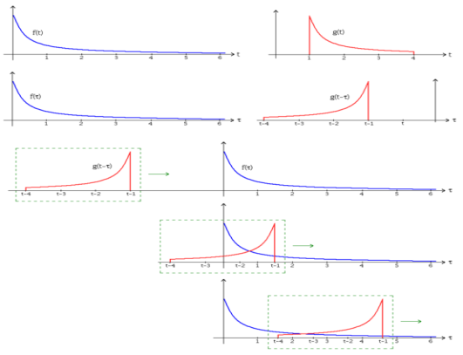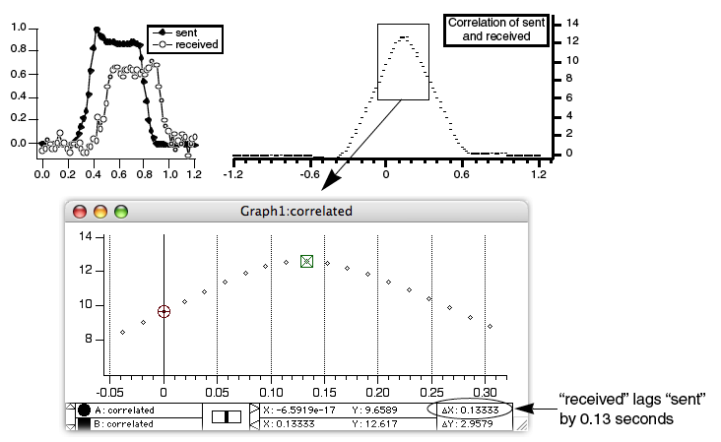

***Figure1.*** *Convolution.* ***Figure2.*** *Correlation.*

***GENERAL PROPOSE:***

To understand, use and apply the operations of correlation and convolution and their relation and applications with the biological signals.

***PROCEDURE:***

This practice is divided in two main sections the first one for convolution and the second one for correlation. First we solve the operation y(t) = x(t)⊗h(t) of the following functions:

1. x(t) = 1, 4<t<6; h(t) = 1, 0<t<4;
2. x(t) = e-t; h(t) = t, 0<t<1;
3. x(t) = 2e-t; h(t) = e-2t;
4. x(t) = 2x - 4, 2<t<3 & x(t) = -2x + 8, 3<t<4; h(t) = e-t;

The results of this operations and the graphics can be seen in the results section.

In order to implement this practice we use the following code:

function practice4() % Digital filters

%% Part I: Convolution

% Variables:

Fs = 1000;

tfin = 10;

t = 0:1/Fs:tfin;

t2 = 0:1/Fs:2*tfin;

funciones = cell(3,4);

% 1)

x = 0*t;

x(4*Fs+1:6*Fs+1) = 2*ones(1,Fs*2+1);

h = 0*t;

h(1:4*Fs+1) = ones(1,4*Fs+1);

y = conv(x,h)/Fs;

funciones = salvar(x,h,y,funciones,1);

% 2)

x = exp(-t);

h = 0*t;

h(1:Fs+1) = 0:1/Fs:1;

y = conv(x,h)/Fs;

funciones = salvar(x,h,y,funciones,2);

% 3)

x = 2*exp(-t);

h = exp(-2*t);

y = conv(x,h)/Fs;

funciones = salvar(x,h,y,funciones,3);

% 4)

x = 0*t;

x(2*Fs+1:3*Fs+1) = 2*(0:1/Fs:1);

x(3*Fs+1:4*Fs+1) = 2*(1:-1/Fs:0);

h = exp(-t);

y = conv(x,h)/Fs;

funciones = salvar(x,h,y,funciones,4);

% Graficar:

lim = [11,6,6,9];

for i = 1:size(funciones,2)

figure

plot(t,funciones{1,i},t,funciones{2,i},t2,funciones{3,i})

legend('x(t)','h(t)','y(t)')

xlabel('Time (s)')

ylabel('Amplitude')

title(['Convolution - Exercise ',num2str(i)])

xlim([0,lim(i)])

end

%% Part II: Correlation

% Given x(t) and y(t) find: a) Rxx, b) Ryy, c) Rxy, d) Ryx

Fs = 1000;

tlim = 2;

t = -tlim:1/Fs:tlim;

t2 = -2*tlim:1/Fs:2*tlim;

funciones = cell(6,1);

% Ex 1)

x = 0*t;

x(1*Fs+1:2*Fs+1) = ones(1,Fs+1);

y = 0*t;

y(2*Fs+1:3*Fs+1) = t(2*Fs+1:3*Fs+1);

funciones{1,1} = x;

funciones{2,1} = y;

funciones{3,1} = xcorr(x,x)/Fs; % Rxx

funciones{4,1} = xcorr(x,y)/Fs; % Rxy

funciones{5,1} = xcorr(y,x)/Fs; % Ryx

funciones{6,1} = xcorr(y,y)/Fs; % Ryy

% Graficar:

lim = [2.5];

for i = 1:size(funciones,2)

figure, plot(t,funciones{1,i},t,funciones{2,i},t2,funciones{3,i},...

t2,funciones{4,i},t2,funciones{5,i},t2,funciones{6,i})

legend('x(t)','y(t)','Rxx','Rxy','Ryx','Ryy')

xlabel('Time (s)')

ylabel('Amplitude')

title(['Correlation - Exercise ',num2str(i)])

xlim([-lim(i),lim(i)])

end

% Biosignal:

[time,signal,Fs,~] = readPhysionet('ecg1');

QRS = 0*time;

QRS(11:18) = signal(68:75); % Extrae conjunto un conjunto QRS

time2 = -max(time)+1/Fs:1/Fs:max(time)-1/Fs;

R = xcorr(signal,QRS)/Fs;

Ra = (R(length(time):end)>0).*R(length(time):end)/max(R);

figure,

subplot(2,2,1)

plot(time,signal)

xlabel('Time (s)')

ylabel('Amplitude')

title('ECG signal')

grid on

xlim([0,3])

subplot(2,2,2)

plot(time,QRS)

xlabel('Time (s)')

ylabel('Amplitude')

title('Extracted QRS from signal')

grid on

xlim([0,0.3])

subplot(2,1,2)

plot(time2,R)

xlabel('Time (s)')

ylabel('Amplitude')

title('Correlation')

grid on

xlim([0,3])

end

In the code we include the following complementary custom functions:

function [time,val,Fs,labels] = readPhysionet(Name)

% Read mat File:

matName = strcat(Name, '.mat');

load(matName);

n = size(val,1);

% Read info File:

infoName = strcat(Name, '.info');

fid = fopen(infoName, 'rt');

fgetl(fid);

fgetl(fid);

fgetl(fid);

freqint = sscanf(fgetl(fid), 'Sampling frequency: %f Hz Sampling interval: %f sec');

Fs = freqint(1);

interval = freqint(2);

fgetl(fid);

% Read data of each signal

signal = cell(1,n);

gain = zeros(1,n);

base = zeros(1,n);

units = cell(1,n);

for i = 1:n

[~, signal(i), gain(i), base(i), units(i)] = strread(fgetl(fid),'%d%s%f%f%s','delimiter','\t');

end

fclose(fid);

% Baseline-corrects and scales the time series:

val(val==-32768) = NaN;

for i = 1:n

val(i, :) = (val(i, :) - base(i)) / gain(i);

end

time = (1:size(val, 2)) * interval;

val = val';

% Gives information of each signal:

labels = cell(1,length(signal));

for i = 1:length(signal)

labels{i} = strcat(signal{i}, ' (', units{i}, ')');

end

end

function [c] = salvar(x,h,y,c,n)

% Save vector:

c{1,n} = x;

c{2,n} = h;

c{3,n} = y;

end

***RESULTS:***

In the first part of convolution we show the results of the operations in the figures 3 to 6.

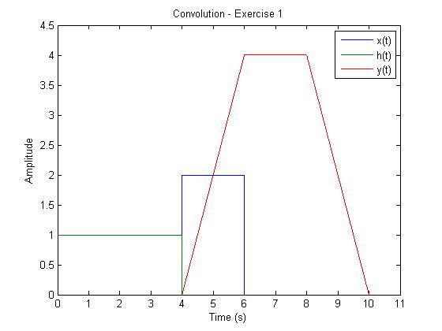

***Figure3.*** *Graphics of first exercise.*

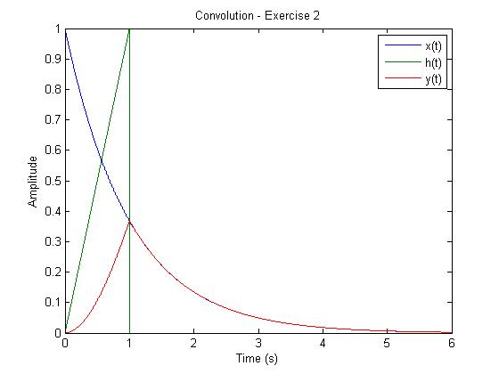

***Figure4.*** *Graphics of second exercise.*

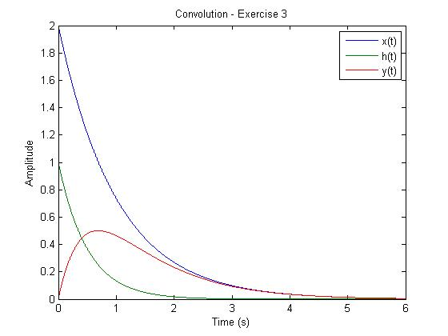

***Figure5.*** *Graphics of third exercise.*

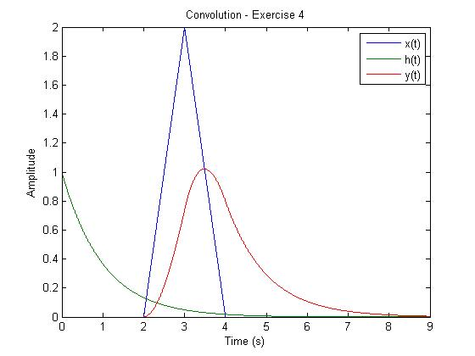

***Figure6.*** *Graphics of fourth exercise.*

As we can see the ranges of the resulting signals are the sum of the original ones and the tendencies change in the limits where the moving signals stop or start crossing the next part of the static signals. This corresponds with our theoretical results and corroborates the results.

In the second part of the practice related with correlation we have two signals and show the autocorrelation of each one, the correlation of the first against the second one and the correlation of the second one against the first one as we can see in figure 7. This shows that, in contrast with convolution, this operation is not commutative.

We also use the correlation to extract information from a biological signal (ECG signal). First we manually extract a QRS wave from the signal and then correlate it with the entire signal. This process can be seen in figure 8.

We can see from this result that the result gives a signal with less noise and “p” and “t” waves attenuated from the original. This kind of operations can be useful to measure cardiac rhythm accurately.

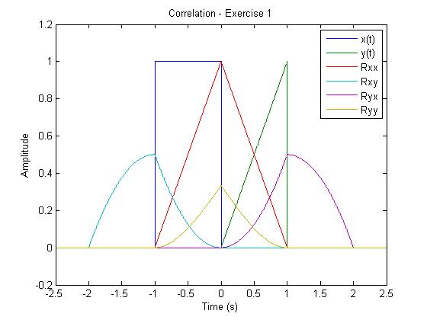

***Figure7.*** *Correlation exercise 1*

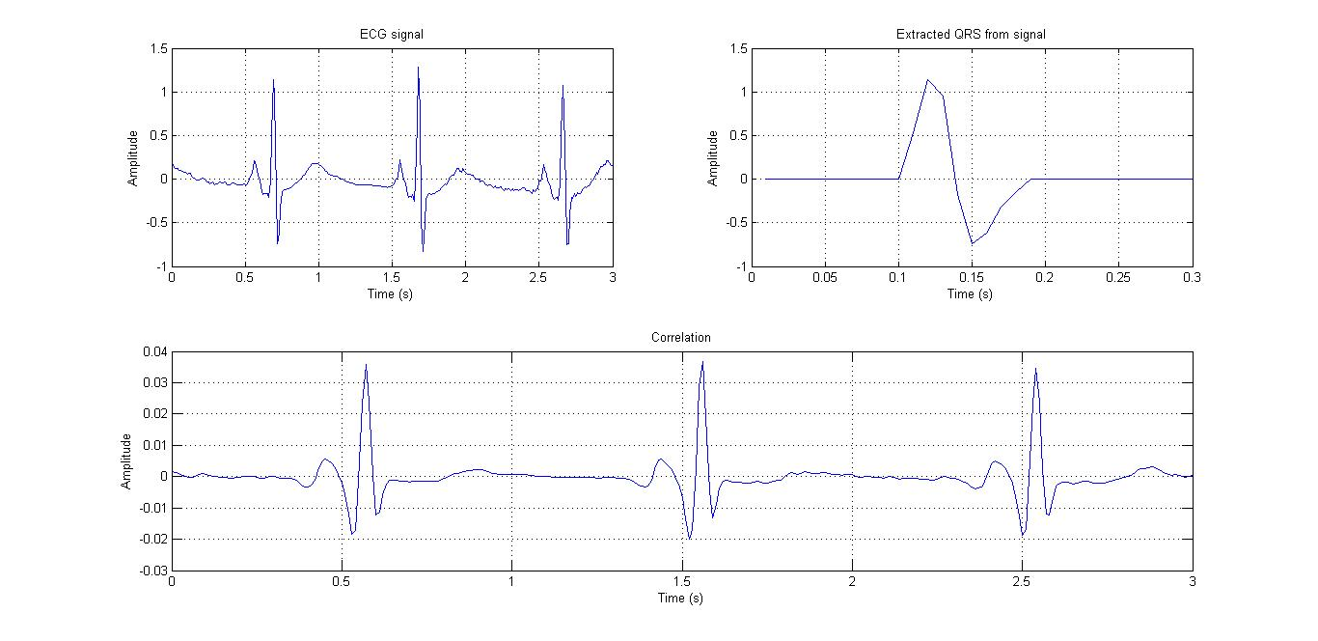

***Figure8.*** *Correlation of ECG signal with QRS wave.*

***CONCLUSION:***

As we can see in the graphs the results correspond with the ones obtained theoretically and ranges are fixed as the sum of both ranges. The convolution works as a filter reshaping the signal and combining the information of the two input signals. When we use convolution in discrete signals we see that the resulting signal have the double of the time of the original ones. This corresponds with the extended ranges of the signal itself.

The correlation gives information about how close one signal is to another. For this reason is useful to extract information of one particular shape that is present several times along the signal. We can also use the autocorrelation to see repetitive patterns in a signal. These patterns can be blurred by noise so this is a way to extract them.

It is important to notice that these tools are useful for signals not only in the biological sense but also in economy, statistics, physics or mathematics. For this reason is important to understand the fundamentals of these operations to extrapolate its use to other areas of knowledge.

***REFERENCES:***

1. Jürgen Stutzki, Convolution, Autocorrelation, Cross-correlation, Power Spectrum: Fourier Transform and its Applications. Soummersemester 2007. Recovered from: [<http://hera.ph1.uni-koeln.de/~stutzki/teaching/FT_appl_2.pdf>].
2. Mitra, Sanjit K. (2006). *Digital Signal Processing, A Computer-Based Approach*. (Third). [First edition in 1998, second in 2001]. New York: McGraw-Hill.
3. Oppenheim, A. V. and Schafer, R. W. (1999). *Discrete-Time Signal Processing*. (Second). [Earlier editions in 1975 and 1989]. Englewood Cliffs, NJ: Prentice-Hall.
4. Parks, T. W. and Burrus, C. S. (1987). *Digital Filter Design*. New York: John Wiley & Sons.
5. Rader, Charles M. (2006, November). The Rise and Fall of Recursive Digital Filters. *IEEE Signal Processing Magazine*,*23*(6), 46–49.